

CS4001NI Programming

50% Individual Coursework

2025-26 Autumn
Credit: 30
Student Name: Rijan Bhattarai
London Met ID: 25029641
College ID: Np01ai4a250028
Assignment Due Date: Click or tap to enter a date.
Assignment Submission Date: Click or tap to enter a date.
Module Leader: Mr. Bikram Poudel
Word Count:

Contents
1. Introduction 3
2. Class Diagram 3
4. Method Description 5
4.1 AIModel 5
4.2 PersonalPlan 7
4.3 ProPlan 9
5. Testing 11

1. Introduction
The coursework focuses on a creating a subscription management system for AI models using Object-oriented programming principles. The goal of this AI model is to design a structured software that run different types of AI subscriptions plans like Personal and Pro plans.
The project consists of three main classes: AIModel, PersonalPlan, and ProPlan. The AIModel class represents the general attributes of an AIModel, such as model name, price, parameter count and context window. The AIModel acts as a parent class whereas the PersonalPlan and ProPlan acts a child class where they extend the parent class to add a few new features in the system like monthly prompt quotas and team collaboration slots.
A programming language is a computer language which is used by programmers to develop programs or other set of instruction for computers to execute (Anon., 2025). The programming language used for this AIModel is Java. Java is a high-level programming language which strongly supports OOP concepts. It provides built-in support for exception handling and GUI development. Also, Java is a platform independent which has a clear and structured syntax which helps in writing organized and readable code.

2. Class Diagram
Class Diagram is a diagram which shows the structure of the systems by showing the classes, attributes and relationships among them (Anon., 2026). Its main purpose is to make easier for developers and designers to understand the system. It serves as a visual tool of communication among team members and stakeholders, bridging the gap between technical and non-technical audiences.

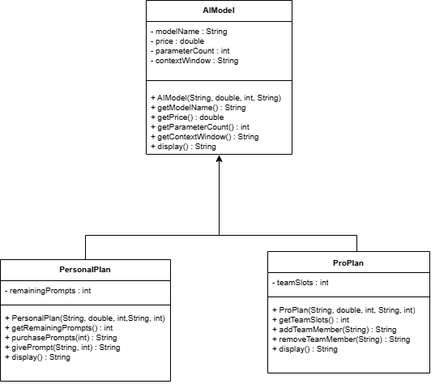
Figure 1. Class Diagram

4. Method Description

4.1 AIModel
There are various methods used in AIModel. They are:
- Constructor
Field | Description
MethodName | AIModel(Constructor)
Parameter | String modelName, double price, int parameterCount, String contextWindow
ReturnType | None
Internal Working | The constructor assigns the four instance variables of the AIModel class where the value is passed as parameters which is assigned to private attributes using “this” keyword.

- getModelName
Field | Description
MethodName | getModelName
Parameter | None
ReturnType | String
Internal Working | Return the value stored in the modelName attribute and allow to access the private variable.

- getPrice

Field | Description
MethodName | getPrice
Parameter | None
ReturnType | double
Internal Working | The method retrieves and returns the value stored in the price attribute.

- getParameterCount

Field | Description
MethodName | getParameterCount
Parameter | None
ReturnType | int
Internal Working | Returns simply the integer value stored in parameterCount and allow the access of private variable.

- getContextWindow

Field | Description
MethodName | getContextWindow
Parameter | Nonw
ReturnType | String
Internal Working | Returns the context window size of the AI model as a string value.

- Display

Field | Description
MethodName | display
Parameter | None
ReturnType | String
Internal Working | Combines the value of all attributes into a String and returns it. This method does not print the value but directly returns the output.

4.2 PersonalPlan
There is also various method used in PersonalPlan. They are:
- Constructor
Field | Description
MethodName | PerosnalPlan(Constructor)
Parameter | String modelName, double price, int parameterCount, String contextWindow, int remainingPrompts
ReturnType | None
Internal Working | Calls the parent class constructor using super() keyword to assign common attributes for the child class. Also assign the remainingPrompts as the instance variables where the value is passed as parameters which is assigned to private attributes using “this” keyword.

- getRemainingPrompts

Field | Description
MethodName | getRemainingPrompts
Parameter | None
ReturnType | int
Internal Working | Returns the current number of remaining prompts available in the monthly quota.

- purchasePrompts

Field | Description
MethodName | purchasePrompts
Parameter | int extraPrompts
ReturnType | String
Internal Working | Check if extraPrompts is less than or equal to zero. If the condition is true, it returns an error message but if the value is positive, then it add the extraPrompts to remaining prompts and return a message showing the updated quota.

- givePrompt

Field | Description
MethodName | givePrompt
Parameter | String promptText, int responseLength
ReturnType | String
Internal Working | Check if remainingPrompts greater than zero. If the condition is true, it decreases remainingPrompts by one and returns a message with prompt text and response length but if remainingPrompts is zero, then it returns a message indicating that the monthly quota has been reached.

- Display(Overridden)

Field | Description
MethodName | display
Parameter | None
ReturnType | String
Internal Working | Calls super.display() function to get the details of parent class. Then appends the remainingPrompts value to the returned string which demonstrate overriding method.

4.3 ProPlan
- Constructor
Field | Description
MethodName | ProPlan(Constructor)
Parameter | String modelName, double price, int parameterCount, String contextWindow, int teamSlots
ReturnType | None
Internal Working | Calls the parent class constructor using super() keyword to assign common attributes for the child class. Also assign the teamSlots as the instance variables where the value is passed as parameters which is assigned to private attributes using “this” keyword.

- getTeamSlots

Field | Description
MethodName | getTeamSlots
Parameter | None
ReturnType | int
Internal Working | Returns the number of available team slots.

- addTeamMember
Field | Description
MethodName | addTeamMember
Parameter | String memberName
ReturnType | String
Internal Working | Check if teamSlots is greater than zero. If the condition is true then, it decreases the teamSlots by one and return a success message but if the teamSlots is zero then it returns an error message indicating no available slots.
- removeTeamMember
Field | Description
MethodName | removeTeamMember
Parameter | String memberName
ReturnType | String
Internal Working | Increases teamSlots by one when a member is removed and returns a confirmation message. This restores an available slot.

- display(Overridden)
Field | Description
MethodName | display
Parameter | None
ReturnType | String
Internal Working | Calls super.display() function to get the details of parent class. Then appends the teamSlots value to the returned string which demonstrate overriding method.

5. Testing

